1. Dice combinations

CODE:

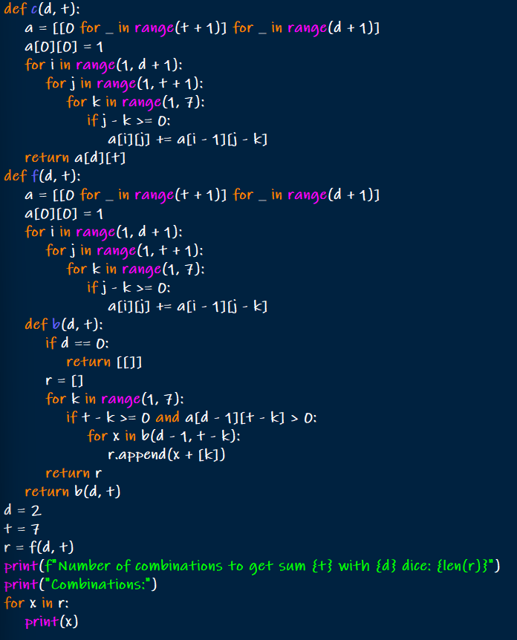

OUTPUT:

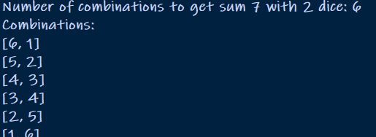

1. TSP implementation

CODE:

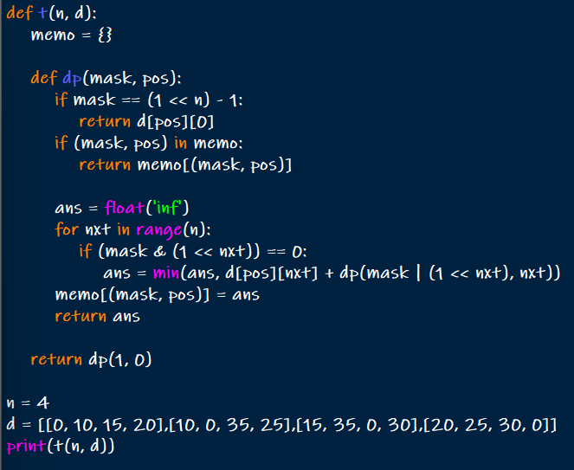

OUTPUT:



1. OBST implementation

CODE:

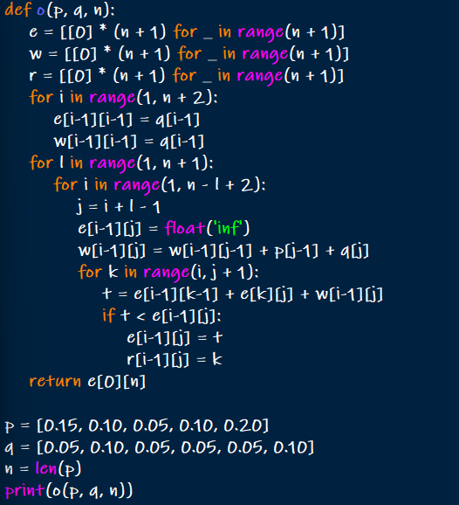

OUTPUT:

